Cau 1
Diagram
- Explain use case
Scenario

Cau 2
Extract noun:
- 1: Describe the system in a paragraph
- 2: Extract noun, related to people, things, system
- 3: Evaluate noun(class/attribute)
- 4: Determine quantity relationship
- 5: Determine object relationship
  - Inheritant: is a
  - Composition: is part of
  - Aggregation: has a
Diagram for the whole system?

Cau 3
Communication diagram

Cau 5

Package diagram
For the system, the packages are designed according to the structure:
- Entity classes are placed together in the model package.
- DAO classes are placed together in the dao package.
- Controller classes are placed together in the controller package.
- JSP pages are kept in the View package. The View package is divided into smaller sub-packages corresponding to the interfaces for different users:
- Pages for functions related to members are placed in the Member package.
- Pages for functions related to staff are placed in the Staff package.
- Pages for functions related to readers are placed in the Reader package.
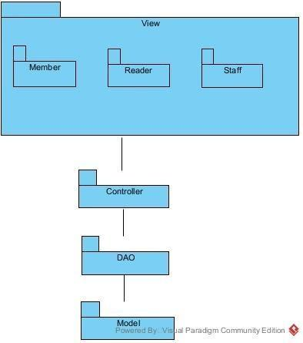

Deployment diagram
For the system, the deployment are designed according to the structure:
- Client: Many users send requests using a Web Browser (Google Chrome 80+, Mozilla Firefox 78+, Microsoft Edge 80+).
- Server: 1 server node using Apache Tomcat 10.1.24, JDK 23, MySQL Connectior 8.4.0, JDBC Driver 12.6.1 to receives requests and executes the application logic.
- Database: 1 database server queries and stores data in SQL Server 16.0.1160.1.
Communication Paths:
- Client <-> Server: Uses the HTTP protocol.
- Server <-> Database: Uses a JDBC.

